Institutional Review Board

Terms of Reference

SPRING 2024

PREFACE

Research that Does Not Require IRB Approval
Research that uses existing data, documents, or records, which are publicly available, or are not publicly available but the researcher has obtained permission to use those data, documents or records from the appropriate individuals or institutions.

Research where adults participate, but where there is no risk to the human participant and the topic is not sensitive (See Section IV for a more detailed description). If in doubt, please contact the member of the IRB in your college or the IRB chair.

Table of Contents
- Institutional Review Board (IRB) and its purpose 2
- Definitions 2
- Types of research for which IRB review and approval must be sought 3
- Types of research for which IRB review and approval need NOT be sought 4
- Responsibilities of the supervisor or main researcher 4
- Responsibilities of the Dean or Head of Department 5
- Responsibilities of the student
- Application for IRB’s review and approval of research projects 5
- Process of IRB’s review and approval projects 6
- Annexes… 7

Institutional Review Board (IRB) and its purpose

The purpose of the KIMEP University Institutional Review Board (IRB) is to ensure that any research involving human participants or whose topic is especially sensitive and which is undertaken either by students or faculty at KIMEP is conducted in an appropriate, ethical manner and risk-free for those participating, including individuals from whom data will be collected, researchers, supervisors, and KIMEP itself, as a research institution.

The IRB will be composed of one full-time faculty member of each college or department/academic division of KIMEP, in case of departments that are not part of a specific college. One of the members shall be appointed chair during each academic year by a simple majority of votes. The minimum amount of faculty present at meetings where the IRB has to review and grant or refuse approval of a research project is three members. The IRB will render all decisions by a simple majority of those present.

The IRB is responsible for enacting policy and guidelines that control research projects and research methods involving the participation of human individuals and/or where the topic of research is especially sensitive. The IRB is also responsible for reviewing and approving research proposals in accordance with that policy and guidelines, without which approval the research project cannot be undertaken or must be discontinued. Furthermore, the IRB is responsible for monitoring the research project after its approval. Depending on the risk level of the approved project, applicants may need to complete bi-annual or annual monitoring reports, which will be reviewed by the IRB (this information will be conveyed in the official approval letter).

The main purpose of this Terms of Reference (ToR) is to explain (1) when students, faculty, and researchers must apply for IRB review and approval; (2) the process and conditions for IRB approval.

This ToR has been drafted following similar ToRs and policies of US universities and IRBs, but trying to simplify their procedures and requisites for approval as much as possible. It has also been taken into account that the kind of research typically undertaken at KIMEP has more to do with social science research than with life science research and that the existing conditions for social science research in Kazakhstan and Central Asia pose challenges that may not exist elsewhere.

The drafters of this ToR welcome any feedback and input from all members of the KIMEP community, which will serve to improve and approve the final version of the ToR, as well as for its future revisions, which will also be done by the IRB when it is deemed necessary.

This ToR is meant to be read together with the flowcharts in its Annex. Relevant documents that need to accompany the application are available on the university website under IRB.

Definitions

- IRB is KIMEP’s Institutional Review Board (see above).

- Research or research project is a systematic investigation, including research development, testing and evaluation, designed to contribute to generalizable knowledge. Research can be conducted by students or faculty, regardless of whether it is part of course-work and regardless of whether it is intended for publication.

- Researcher is anyone employed by KIMEP and/or who intends to conduct research at KIMEP or to use KIMEP’s facilities or resources.

- Main researcher is the researcher who leads a research project.

- Student is anyone registered in any of the programs offered at KIMEP or at any other institution and who intends to do research at KIMEP or use KIMEP’s facilities or resources.

- Supervisor is any faculty member in charge of supervising student research, but who does not conduct the research himself/herself.

- Contact person is a researcher who participates in the research project and who is designated to be available for any participant in the research who wishes to contact him/her in order to request information, make complaints, etc. The contact person and the main researcher may be the same person, at the choice of the members of the research team. In case of research conducted by students, the contact person is the supervisor.

- Faculty is any faculty or researcher employed by KIMEP (full time or adjunct) or by any other institution.

- Sensitive research is research which is politically or culturally sensitive in nature – e.g. corruption, terrorism, religion – or research which poses reputational, economic, or legal risks for KIMEP University – e.g. if the research methods or the results of the research were widely known, KIMEP might suffer some sort of serious retaliation as an institution. Sensitive research also includes research done with vulnerable populations.

- Participant is any human participating in the research and with whom the researcher has personal contact in order to collect data from that participant; e.g. individuals being interviewed by the researcher or answering the questions of a survey prepared by the researcher.

- Minor is anybody under 18.

- Adult is anybody 18 or above.

- Especially vulnerable individuals are those who are reasonably considered to be in especial need of protection; e.g. minors, individuals who are exposed to positions of power, mentally challenged individuals, immigrants, or individuals at risk of exclusion, regardless of their age.

- Risk to the human participant is any significant and reasonably probable risk of harm of a physical, psychological, social, economic, reputational or legal nature caused to the participant by the research process or by the process of disseminating the results of the research.

- Informed Consent Form is the form on the university website, which every adult participant must fill out and sign before participating in any research project and in accordance with this ToR.

- Participant Information Sheet is the form with the ethical implications of the research project. This form will be given to participants in order to familiarize themselves with the study and ask questions if necessary.

- Assent Form is on the university website and which every minor participant (7 to 17 years of age) must fill out and sign before participating in any research project and in accordance with this ToR. In the case of minors, legal guardians must also fill out and sign a consent form to allow the minor to partake in the research.

Types of research for which IRB review and approval must be sought

A researcher must apply for IRB’s review and obtain IRB’s approval for a research project in the following cases:

- Research involving human participants, i.e. where there is personal interaction (online or in person) between the researcher(s) and the human participants, provided that the human participants:

  - are minors or especially vulnerable individuals, as defined above;

  - are adults and there is risk for them, as defined above.

- Research whose topic is sensitive.

The cases where IRB review and approval must be sought and obtained are also explained using the flowchart in Annex I.

Types of research for which IRB review and approval need NOT be sought

A researcher need NOT apply for IRB’s review and obtain IRB’s approval for a research project in the following cases:

- Research using existing data, documents, or records which are publicly available.

- Research using existing data, documents, or records which are not publicly available but where the researcher(s) have obtained permission to use those data, documents or records from the individual or institution who has rights over them or otherwise keeps them.

- Research where adults participate, but where there is no risk to the human participant and the topic is not sensitive. An informed consent form will still be necessary in these cases, in accordance with this ToR.

- Research which uses simple observation of public behavior, without further contact between the researcher and the human individual.

- Research in education settings on instructional techniques, curricula, or classroom-management methods, except where their own students are participants.

Responsibilities of the supervisor or main researcher

The supervisor or main researcher will be responsible for:

- Assessing whether IRB’s review and approval is required in accordance with this ToR.

- Applying for IRB’s review and approval where it is required in accordance with this ToR.

- Providing participants with the Participant Information Sheet in order to make an informed decision to partake in the study or not.

- Obtaining signed Informed Consent Forms/Assent Forms from every participant in the research or from their legal guardians, making sure that the participants are aware of the rights that they have as participants in the research project, in accordance with this ToR.

- Making sure that an Informed Consent Form and Participant Information Form are included in the documents or digital platforms used to collect data from human participants so that they can easily find it. Alternatively, as in the case of oral interviews with human participants, making sure that every participant has a copy of the informed consent form and Participant Information Form or is otherwise aware of its contents and of the rights that they have as participants in the research project, in accordance with this ToR.

- Obtaining relevant permission letters from organizations where research will be conducted.

- Making sure that the privacy of the human participants as well as the confidentiality of the data collected from them will be safeguarded throughout all stages of the research project.

- Making sure that all researchers who participate in the research project received ethical training and are aware of the contents, requirements and procedures of this ToR.

- Filing the following documents with the relevant Dean at KIMEP where the supervisor or researcher works, after obtaining IRB’s approval:

  - Proposal/Ethical application form
  - Signed Informed Consent/Assent Forms.
  - Additional forms that were part of the application of the research project was granted (and any minutes of past rejections of approval), including any IRB’s indications as to how the research must be conducted.

  - Evidence of permission obtained to use research data that is not publicly accessible.

  - All other documents, which are part of the process of obtaining IRB’s approval, in accordance with this ToR, including letter of approval from IRB.

  - Ensuring that the research project, including the dissemination of results, is conducted in a generally ethical manner at all times.

Responsibilities of the Dean or Head of Department

The Dean or Head of Department where the supervisor or researcher works will be responsible for opening a file where the documents referred to in the previous section will be archived and kept. The Dean or Head of Department is not responsible for monitoring the research project as far as compliance of the research with this ToR is concerned.

Informed consent

Informed consent is required whenever there are human participants in the research, in order to collect data from those participants.

As a condition for IRB’s approval, every participant must sign the Informed Consent Form (available on IRB website) after been provided with the information on the Participant Information Form (available on the IRB website). In case of minors, the supervisor or main researcher is responsible for obtaining a signed informed consent form from the parents or legal guardians of those participants, as well as an assent form from children 7 to 17 years of age.

As a condition for IRB’s approval, in cases where the participants are adults, but where there is risk for those participants, as well as in cases where there is no such risk, an informed consent form must be included in all the data collection materials and the supervisor or main researcher is responsible for making sure that all participants can easily find it and read it.

Application for IRB’s review and approval of research projects

Where IRB’s review and approval are required, in accordance with this ToR, the supervisor or main researcher shall submit to the chair of the IRB the following:

- A description of the research project, including (a) its purpose and goals, (b) the intended data collection methods, (c) the sensitivity of the topic and (d) future dissemination of results (e) ethical aspects to be addressed. Please refer to the recommended applications form on the IRB website.

- Name and signature of the supervisor or researcher(s) and of the contact person.

- Types of human participants, as defined in this ToR, e.g. minors, adults or especially vulnerable persons.

- Risks for human participants, as defined in this ToR.

- A description of the type of informed consent that is required and how it is going to be obtained from participants; i.e. signed informed consent forms included in the
documents or digital platforms used to collect data from the participants.

- A description of how the privacy of the human participants as well as the confidentiality of the data collected is going to be safeguarded.

- A detailed Participant Information Form

The above information shall be submitted by the main researcher to the chair of the IRB using the application form on the university website. The main researcher may submit any other information or document he considers relevant for the purpose of IRB’s review and approval. The process for requesting IRB review and approval is explained using the flowchart in Annex I.

Process of IRB’s review and approval projects

Once the chair of the IRB is satisfied that the application for IRB’s review is complete, in accordance with this ToR, they shall communicate to the applicant that no more information is needed or, alternatively, they shall request more information. The chair of the IRB shall then convene the IRB to discuss the application.

The IRB’s approval of the research project shall be granted if a majority of the members of the IRB present at the meeting are satisfied of the following:

- The applicant submitted all the information required, in accordance with this ToR.

- Participation in the research project is voluntary through all its stages.

- The intended procedures for obtaining the consent of the human participants are in accordance with this ToR.

- The methods to collect and store data from the human participants, as well as the intended process of disseminating the results of the research respect the privacy and confidentiality of the human participants and do not pose any significant and probable harm of physical, psychological, social, economic, reputational or legal harm for them.

- The data collected will be used only for the purposes for which consent was obtained and data will be appropriately stored and destroyed.

- There is no significant and probable risk for KIMEP University’s reputation either as a result of the research itself or of the dissemination of its results.

The IRB’s decision to approve the research project shall be communicated to the applicant and will be recorded in the minutes. If the project is rejected by a majority of members of the IRB, this will also be communicated to the applicant, explaining the decision in detail, as well as informing the applicant of the right to re-apply to IRB and what is needed for a new and successful application.

The IRB will communicate its approval through an official letter to the applicant signed by the chair of the board. The official letter will be CC’d to the dean or head of department of the main researcher, if they are employed or studying at KIMEP. The letter will note other recommendations of the committee, need for monitoring reports if any and provide the IRB approval number.

The IRB approval number will be the four digits of the year of the approval, followed by a hyphen and then the number reflecting how many approvals have been made up to that time. For example, 2024-10 is the approval number of the 10th approved project of the year 2024.

Annex Follows

Annex I: Process for requesting IRB review and approval (flowchart)
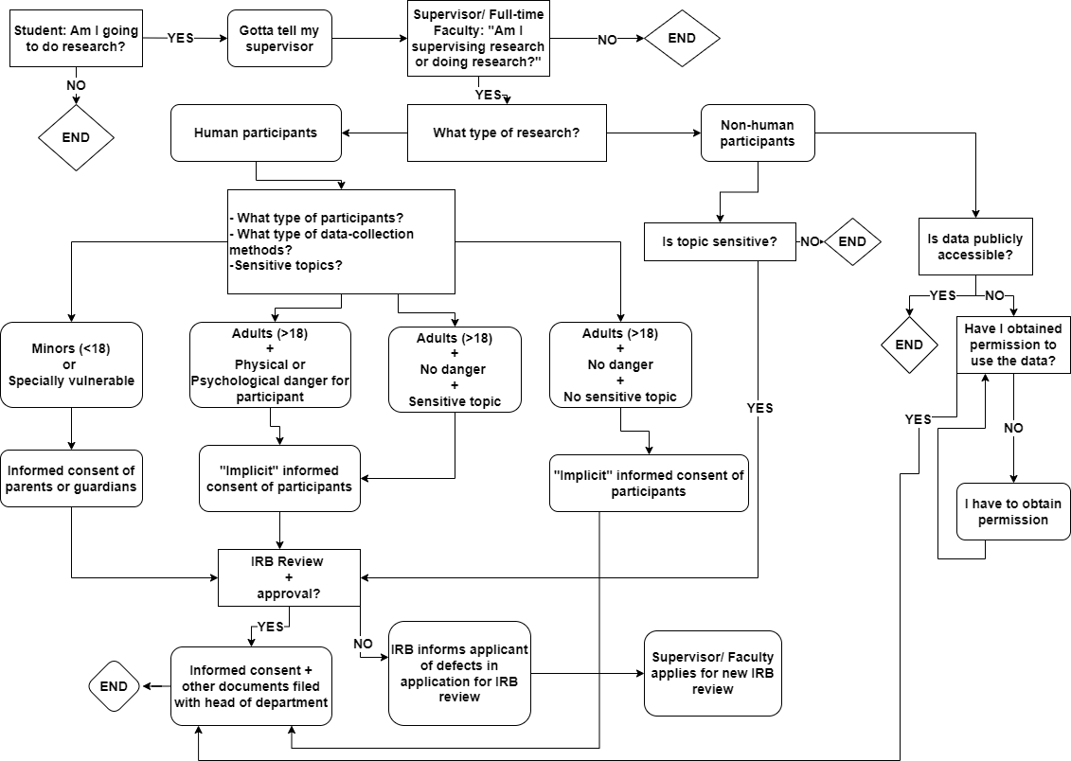

Annex II: Process for making decisions on requested IRB review and approval (flowchart)
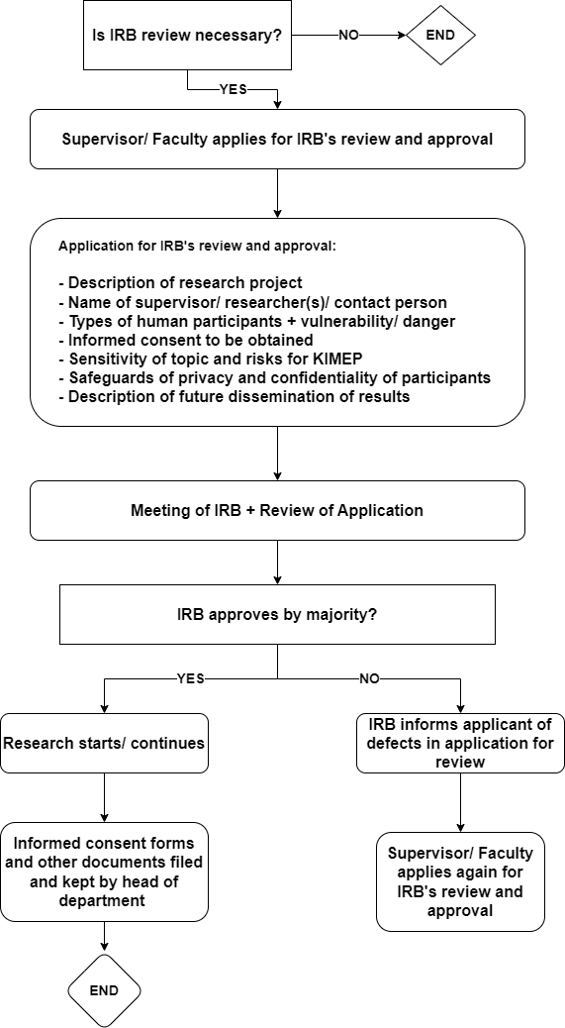

CODE OF CONDUCT FOR RESEARCHERS
This code of conduct is applicable to all KIMEP researchers/student researchers/affiliate researchers.
As a researcher of the KIMEP University, I subscribe to the rules of the Institutional Review Board (IRB), all applicable policies of KIMEP, as well as all national and international laws and regulations applicable to my field of study. Furthermore, I commit myself to abide by the ethical principles and responsibilities as set out in the Code of Ethics and Research Conduct stipulated by ____________________________________________ (e.g. Singapore Statement on Research Integrity; British Psychological Society; American Psychological Association), in any and all research endeavors that I undertake as a researcher of KIMEP.

By signing this code of conduct I take full responsibility for the ethically execution of my research project.

Name Signature Date

RISK LEVEL DESCRIPTORS FOR HUMAN PARTICIPANTS FOR

USE AT KIMEP UNIVERSITY

INTRODUCTION

The risk level descriptors (RLDs) have been adopted from those utilised by the North-West University, South Africa. This document is not only concerned with harm to the participants themselves, but also to the researchers, community, or other role players. This document provides guidelines that are applicable across disciplines.

DEFINITION OF KEY TERMS

  - Risk is the possibility that research may cause different types of harm to any participant. For the purpose of this document a risk is seen as the potential of harm occurring to a participant as a result of participation in research.
  - Harm could be anything that has a negative effect on participant’s welfare. Any research with humans must be preceded by an assessment of potential harm or inconvenience and possible benefits of the potential participant. A basic prerequisite for conducting the risk-benefit ratio analysis is a critical reflection on and deliberation about the risks and the benefits by both the researcher and the ethics committee.
  - Benefits are direct if it positively affects the interest or welfare of the participant, e.g. learning a new skill or service received; or indirect if it is to the benefit of the researcher, scientific field of knowledge, or the community, e.g. improvement in policy or community programme.
  - Vulnerability refers to the diminished ability to fully safeguard one’s own interests in the context of a specific research project. This may be caused by limited capacity or limited access to social goods like rights, opportunities, and power; limited freedom to make choices; or relatively incapable of protecting own interest. Vulnerability is not an absolute condition but rather occurs on a sliding scale depending on personal or environmental circumstances. Vulnerability also refers to participants who are exposed to positions of power.
  - Adverse event refers to any undesirable or unintended response or occurrence in a research participant during research (related or not related to the research)
  - Researchers with a conflict of interest (declared) increase the risk level of the research. Conflict of interest is where a person’s individual interests or responsibilities have the potential to influence the carrying out of his or her institutional role or professional obligations in research.

  - Researchers have an obligation to ensure that the risks inherent in the proposed research have been reduced to the minimum necessary to achieve the research objective.
  - Clear measures and precautions should be in place to mitigate or avoid the potential identified risks.

RISK LEVELS for RESEARCH WITH ADULT PARTICIPANTS

Adjusted from: “Getting Ethics Approval for Your Research Project. Research Ethics Committee: Humanities. March 2015” University of Stellenbosch and guidance from the Department of Health. Second edition. Ethics in Health Research. Principles, Processes and Structures, 2015.

Risk Category | Definition | Explanation and/or examples
No risk | No contact with human participants, animals or environment | - Systematic reviews  - Literature review  - Document analysis (e.g. in public domain)
Minimal, low, or negligible risk | The potential of harm or discomfort anticipated in the research are not greater in and of themselves, than those ordinarily encountered in daily life.  Research in which the only foreseeable risk is one of minimal discomfort or inconvenience.  The research will collect information that would generally not be regarded as sensitive, such as opinions rather than personal information. | - There is a very small possibility of risk, if any  - Market research surveys  - Research on an uncontroversial topic  - The study may be conducted through interviews, surveys and participant observation.  - Research that focuses on opinions and/or perceptions.  - Research not having any sensitive matters
Medium risk (above minimal risk) | Research in which there is a potential risk of unexpected negative consequences, harm or discomfort, eg. physical, psychological, social, or environmental harm; but where appropriate steps can be taken to mitigate or reduce overall risk. Remedial actions can be undertaken should harm occur. | The risk of harm is considered reasonable relative to the envisaged benefit of the study, e.g. new knowledge  - Anticipated knowledge gained.  - It involves personal sensitive information rather t han opinions or attitudes or a combination of these.  - The information needs to be collected with personal identifiers (name, student number, etc.).

- It involves a vulnerable or marginalized group, e.g. people living with HIV, disabled individuals, etc.
- It uses patient records in existing health systems
- It uses laboratory test results of patients in existing health systems
High Risk | Research in which there is a real and foreseeable risk of unexpected negative consequences, harm and discomfort, and which may lead to serious adverse consequences if not managed in a responsible manner. | There is a higher possibility of various types of harm and adverse consequences.  This may involve pharmaceutical drug research.  - Research involving highly sensitive topic  - Research involving vulnerable and marginalized communities e.g. people with multiple vulnerabilities.  - Research investigating illegal activities among participants  - Research involving drawing of bloods, dry blood spots, etc.  - Research with minors  - Research with adults  with mental incapacity  - Research that has impact on animal wellbeing  - Research that has impact on the environment

ADDENDUM: RISK EVALUATION FORM FOR RESEARCH WITH HUMAN PARTICIPANTS

This form assists in identifying the nature of harm for low, minimum and high risk studies

Types of risks | Example | Potential  (Mark with a √ if the probability exist) | Extent  1 – minimal discomfort  2 – medium discomfort  3 – high discomfort | Justification | Precaution
Physical harm | Fatigue
 | Headaches
 | Physical discomfort
 | Muscle tension
 | Physical side-effects
 | Injury
 | Toxicity
 | Loss of physical capability
 | Loss of safety
Psychological | Emotional discomfort
harm
 | Emotional dependency
 | Loss of mental capability
 | Deception
 | Coercion
 | Emotional distress
 | Boredom
 | Inconvenience
 | Self-disclosure
 | Embarrassment
 | Anxiety
 | Fear
 | Anger
 | Sadness
 | Emotional trauma
 | Loss of privacy and
 | confidentiality
 | Loss of autonomy
 | Loss of freedom of choice
Social harm | Negative effects of interactions
 | Loss of status or social standing
 | Loss of reputation
 | Stigmatization
 | Discrimination
Legal harm | Arrest
 | Conviction
 | Incarceration if researchers are bound to report certain actions
Economic harm | Direct or indirect financial cost e.g. travelling or child care
 | Loss of income not being on the job
 | Time spent in the research
Dignitary harm (harm to dignity) | Not treated as a person with own values
 | Preferences and commitments are mere a means to an end e.g. informed consent
Community harm | General community knowledge becomes known
 | Abuse indigenous knowledge

IRB Stamp

INFORMED CONSENT FORM

TITLE OF THE RESEARCH STUDY:

ETHICS REFERENCE NUMBER:

PRINCIPAL RESEARCHER / SUPERVISOR:
POST GRADUATE STUDENT:

ADDRESS:

CONTACT NUMBER:

Please take some time to read the information presented here, which will explain the details of this study. Please ask the researcher or person explaining the research to you any questions about any part of this study that you do not fully understand. Also, your participation is entirely voluntary. If you say no, this will not affect you negatively in any way whatsoever. You are also free to withdraw from the study at any point, even if you do agree to take part now.

This study has been approved by the Institutional Review Board (IRB) of KIMEP University (00000-00-A1) and will be conducted according to strict ethical guidelines and principles. It might be necessary for the IRB members or other relevant people to inspect the research records.

Short description of the study

Reason for your participation

What will be expected of you?
Compensation and/or costs
Possible benefits, risks, and prevention of risks

Confidentiality and privacy

How will the findings or samples be used

Storage and destruction of data

How will you know about the results of this research?

Is there anything else that you should know or do?
- You can contact ……. at ……. if you have any further questions or have any problems.
- You can also contact the IRB via …….at …… or @kimep.kz if you have any concerns that were not answered about the research or if you have complaints about the research.
- You will receive a copy of this information and consent form for your own purposes.

Declaration by participant

By signing below, I …………………………………..………. agree to take part in the research study titled “ ”.

I declare that:

- I have read this information/it was explained to me by a trusted person in a language with which I am fluent and comfortable.
- The research was clearly explained to me.
- I have had a chance to ask questions to both the person getting the consent from me, as well as the researcher and all my questions have been answered.
- I understand that taking part in this study is voluntary and I have not been pressurised to take part.
- I may choose to leave the study at any time and will not be handled in a negative way if I do so.
- I may be asked to leave the study before it has finished, if the researcher feels it is in the best interest, or if I do not follow the study plan, as agreed to.

Signed at (place) ......................…........…………….. on (date) …………....……….. 20....

Signature of participant Signature of witness

Declaration by person obtaining consent (if not the researcher)

I (name) ……………………………………………..……… declare that:

- I clearly and in detail explained the information in this document to

………………………………………………….
- I did/did not use an interpreter.
- I encouraged him/her to ask questions and took adequate time to answer them.
- I am satisfied that he/she adequately understands all aspects of the research, as discussed above
- I gave him/her time to discuss it with others if he/she wished to do so.

Signed at (place) ......................…........…………….. on (date) …………....……….. 20....

Signature of person obtaining consent

Declaration by researcher

I …….. declare that:

- I explained the information in this document to ……………………………….. or I had it explained by …………………………………… who I trained for this purpose.
- I did/did not use an interpreter
- I encouraged him/her to ask questions and took adequate time to answer them
or I was available should he/she want to ask any further questions.
- The informed consent was obtained by an independent person.
- I am satisfied that he/she adequately understands all aspects of the research, as described above.
- I am satisfied that he/she had time to discuss it with others if he/she wished to do so.

Signed at (place) ......................…........…………….. on (date) …………....……….. 20....

Signature of researcher

IRB Stamp

[This serves as a general example. Because this form should be used for youth between 7 and 17 years of age, you should adapt the form to the developmental phase of the child.]

INFORMED ASSENT FORM

TITLE OF THE RESEARCH STUDY:

ETHICS REFERENCE NUMBER:

PRINCIPAL RESEARCHER / SUPERVISOR:
POST GRADUATE STUDENT:

ADDRESS:

CONTACT NUMBER:

This form is very important, because it tells you what the research is about and what you need to know. It will help you to decide if you want to be part of the research or not. Remember, you DO NOT have to take part. No-one can tell you to take part and nothing will happen to you if you decide not to take part. Even if you decide to take part, you can change your mind later not to take part.

The Institutional Review Board (IRB) of KIMEP University (00000-00-A1) gave permission for this study to be done and strict ethical rules will be followed.

What is this study about?

Why do we want you to take part?

What will we expect you to do?
Will you receive any money or other gifts?
Will there be risks and how will we try to prevent them?

How will this study benefit you?

Will anybody know that you took part in the research?

How will we use the information that you give us?

How will be store your information and how will be destroy it when we are finished with the study?

How will you know about the results of this research?

Is there anything else that you should know or do?
- You or your legal guardians can contact ……. at ……. if you have any further questions or have any problems.
- You can also contact the IRB via …….at …… or @kimep.kz if you have any concerns that were not answered about the research or if you have complaints about the research.
- You will receive a copy of this information and consent form for your own purposes.

Declaration by participant

By signing below, I …………………………………..………. agree to take part in the research study titled “ ”.

I declare that:

- I have read this information/it was explained to me by a trusted person in a language with which I am fluent and comfortable.
- The research was clearly explained to me.
- I have had a chance to ask questions to both the person getting the consent from me, as well as the researcher and all my questions have been answered.
- I understand that taking part in this study is voluntary and I have not been pressurised to take part.
- I may choose to leave the study at any time and will not be handled in a negative way if I do so.
- I may be asked to leave the study before it has finished, if the researcher feels it is in the best interest, or if I do not follow the study plan, as agreed to.

Signed at (place) ......................…........…………….. on (date) …………....……….. 20....

Signature of participant Signature of witness

Declaration by person obtaining consent (if not the researcher)

I (name) ……………………………………………..……… declare that:

- I clearly and in detail explained the information in this document to

………………………………………………….
- I did/did not use an interpreter.
- I encouraged him/her to ask questions and took adequate time to answer them.
- I am satisfied that he/she adequately understands all aspects of the research, as discussed above
- I gave him/her time to discuss it with others if he/she wished to do so.

Signed at (place) ......................…........…………….. on (date) …………....……….. 20....

Signature of person obtaining consent

Declaration by researcher

I …….. declare that:

- I explained the information in this document to ……………………………….. or I had it explained by …………………………………… who I trained for this purpose.
- I did/did not use an interpreter
- I encouraged him/her to ask questions and took adequate time to answer them
or I was available should he/she want to ask any further questions.
- The informed consent was obtained by an independent person.
- I am satisfied that he/she adequately understands all aspects of the research, as described above.
- I am satisfied that he/she had time to discuss it with others if he/she wished to do so.

Signed at (place) ......................…........…………….. on (date) …………....……….. 20....

Signature of researcher

IRB Stamp

PARTICIPANT INFORMATION SHEET

TITLE OF THE RESEARCH STUDY:

ETHICS REFERENCE NUMBER:

PRINCIPAL RESEARCHER / SUPERVISOR:
POST GRADUATE STUDENT:

ADDRESS:

CONTACT NUMBER:

Please take some time to read the information presented here, which will explain the details of this study. Please ask the researcher or person explaining the research to you any questions about any part of this study that you do not fully understand. Also, your participation is entirely voluntary. If you say no, this will not affect you negatively in any way whatsoever. You are also free to withdraw from the study at any point, even if you do agree to take part now.

This study has been approved by the Institutional Review Board (IRB) of KIMEP University (00000-00-A1) and will be conducted according to strict ethical guidelines and principles. It might be necessary for the IRB members or other relevant people to inspect the research records.

Short description of the study

Reason for your participation

What will be expected of you?
Compensation and/or costs
Possible benefits, risks, and prevention of risks

Confidentiality and privacy

How will the findings or samples be used

Storage and destruction of data

How will you know about the results of this research?

Is there anything else that you should know or do?
- You can contact ……. at ……. if you have any further questions or have any problems.
- You can also contact the IRB via …….at …… or @kimep.kz if you have any concerns that were not answered about the research or if you have complaints about the research.

- You will receive a copy of this information and consent form for your own purposes.

IRB Research Monitoring Report
Confidential! This document contains confidential information that is intended strictly and exclusively for the applicant and the IRB of KIMEP University. Should this document, or parts thereof, erroneously come in to your possession, you are requested to destroy it or return it to the IRB without delay. Unauthorized possession, reading, studying, copying, or distribution thereof is illegal and punishable.

Please complete the following sections as indicated:
Sections A to E: All researchers
Section B: Only for quantitative research
Section C: Only for qualitative research
Section D: Only for previously collected data or biological samples
Section E: Amendments
Section F: Status of the study

SECTION A: GENERAL INFORMATION AND PROGRESS

- Principal Investigator/Supervisor
Surname: Click here to enter text.
Name: Click here to enter text.
Initials: Click here to enter text.
Title: Click here to enter text.
College: Click here to enter text.
Department: Click here to enter text.
E-mail: Click here to enter text.
Office number: Click here to enter text.
Cellphone: Click here to enter text.

- Student Details: Click here to enter text.
Surname: Click here to enter text.
Name: Click here to enter text.
Initials: Click here to enter text.
Title: Click here to enter text.
Student ID number: Click here to enter text.
College: Click here to enter text.
Department: Click here to enter text.
E-mail: Click here to enter text.

- Details of approved proposal
Title: Click here to enter text.
IRB approved number: Click here to enter text.
Risk level: None☐ Minimal☐ Medium☐ High☐
Approval date: Click here to enter a date.
Expire date: Click here to enter a date.
Are there any affiliated studies linked to this project? Click here to enter text.
If yes, please indicate
- Title: Click here to enter text.
- Researchers/students
Surname | Name | College
Click here to enter text. | Click here to enter text. | Click here to enter text.
Click here to enter text. | Click here to enter text. | Click here to enter text.
Click here to enter text. | Click here to enter text. | Click here to enter text.

- If funded, does the project still meet the necessary requirements? Yes☐ No☐
- Give a short summary of the progress to date.
Click here to enter text.
- Describe any ethical issues that may have arisen.
Click here to enter text.
- Describe how the research process have been monitored up to now.
Click here to enter text.
- If any external organizations had to monitor the process, please provide detail.
Click here to enter text.

SECTION B: ONLY FOR QUANTITATIVE RESEARCH

- Initial intended number of participants: Click here to enter text.
- Actual number of participants: Click here to enter text.
- Number of participants who withdrew by choice. Please provide reasons.
Click here to enter text.
- Number of participants who withdrew due to adverse events. Please provide reasons.
Click here to enter text.
- Number of participants lost to follow-up. Please provide reasons.
Click here to enter text.

SECTION C: ONLY FOR QUALITATIVE RESEARCH

- How many participants actively participated? Click here to enter text.
- How was data saturation obtained?
Click here to enter text.
- Number of participants who withdrew by choice. Please provide reasons.
Click here to enter text.
- Number of participants who withdrew due to adverse events. Please provide reasons.
Click here to enter text.
- Number of participants lost to follow-up. Please provide reasons.
Click here to enter text.

SECTION D: ONLY FOR PREVIOUSLY COLLECTED DATA OR BIOLOGICAL SAMPLES

- Biological samples
- How many biological samples were planned to be used? Click here to enter text.
- How many actual samples have been examined? Click here to enter text.
- Databases
- Was the received database anonymized? Please describe the process.
Click here to enter text.
- Was the data base password protected? Click here to enter text.

SECTION E: AMENDMENTS

Was the study amended or changed in the past year? Please describe.
Click here to enter text.
Was approval obtained for the amendment? Please provide details.
Click here to enter text.

SECTION F: STATUS OF THE STUDY

- Has the study been completed and does this serve as the final report? Click here to enter text.
- Has the study been terminated? Click here to enter text.
- Provide date: Click here to enter a date.
- Provide reason: Click here to enter text.
- Was the IRB notified? Click here to enter text.
- Does the project have to continue into the following year? Click here to enter text.

By signing this document, I certify that the information provided is accurate and complete.

Full name and surname: Click here to enter text.

Signature Date Click here to enter a date.

Some sections of this document have been adapted from HREC documents of the North-west University

